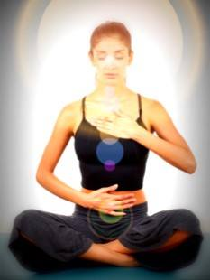
The Natural Breath
  - 200 Hour Yoga Teacher Training Program
  - Summer 2018

Scholarship Application

Just Breathe Yoga Studio will be offering a partial scholarship to our Summer 2018 Yoga Teacher Training Program. Award of the scholarship will be dependent on need as well as responses to required essay questions. Only ONE scholarship will be awarded for Summer 2018. Deadline is May 1st.
Please note: Awarded individual MUST commit to ENTIRE teacher training program, without exception. If individual drops out of program without completion, individual is required to refund the awarded scholarship monies in FULL to Just Breathe Yoga Studio within 30 days following their leaving the program.
Please be certain that your name, address, email, phone and date of submission is written on top of summitted document. Applications MUST be typed, with complete sentences and with w 12-point font. Applications can be emailed to yoga@justbreatheyogastudio.com or sent to Just Breathe Yoga Studio at 1918 N James St, Rome, NY 13440. All submissions MUST be received BY May 1st, 2018, and meet the above criteria, any application that doesn’t will be discarded.

Please submit your responses to the following questions:
- What is YOUR definition of yoga?
- Why do you want to become a yoga instructor? What has inspired you to consider becoming one?
- Why should you be considered for this scholarship? (please state here your need for the financial assistance)
- How do you see yourself utilizing your yoga teacher certification once completed?

If you have any questions, please feel free to contact
Nicole Hayman-Sherman ERYT-500, at Just Breathe Yoga Studio.

